Practical 3
Definition : Apply filtering, sorting, and group-by operations to calculate average salary by department.
Outcomes / Learning : This project taught me how to use pandas in Python to perform fundamental data manipulation tasks like filtering, sorting, and grouping data to derive insights.

Required Tool : The Experiment was performed using a Python Environment using Pandas Library, a Standard tool for Data Analysis.

Working : The code analyzes employee data using the pandas library. It demonstrates how to filter the dataset to find specific employees, sort it based on salary, and use groupby to calculate average salaries for each department.

Step 1 : Imports the pandas library and reads a CSV file into a DataFrame.
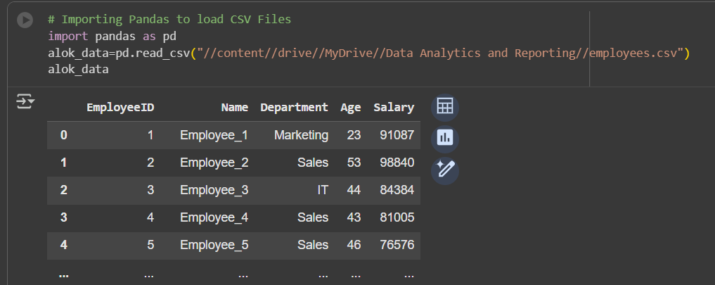
Step 2 : Filters the DataFrame to select only employees from the 'Sales' department.
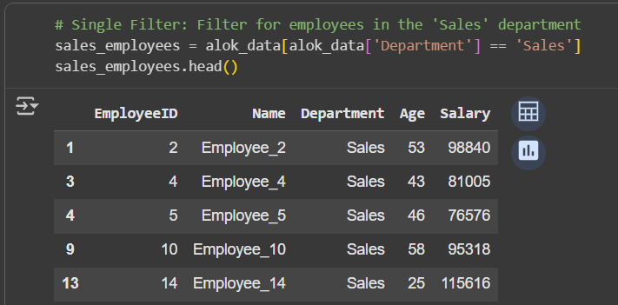

Step 3 : Filters the DataFrame to select employees from the 'IT' department with a salary over $90,000.
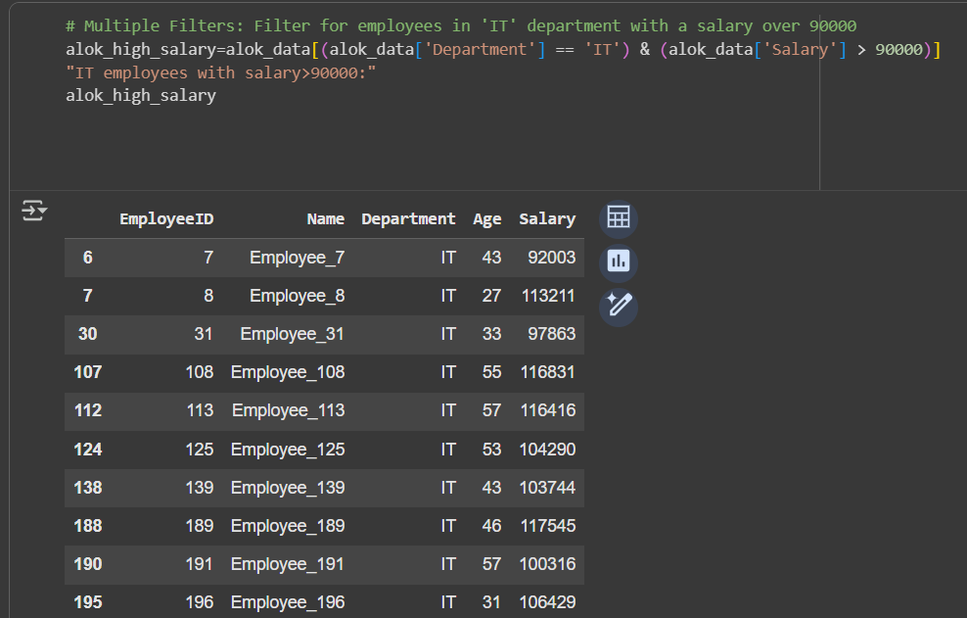

Step 4 : Sorts the DataFrame by the 'Salary' column in descending order.
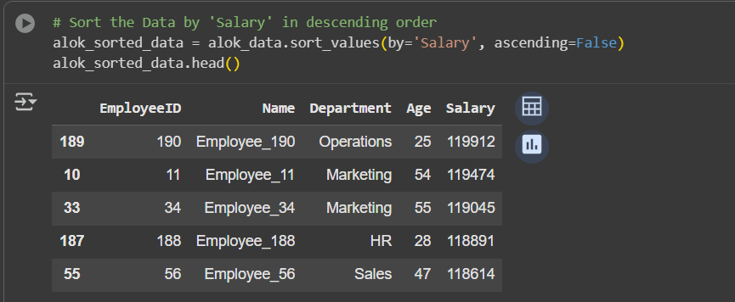

Step 5 : Calculates the average salary for each unique department using the groupby() function.
